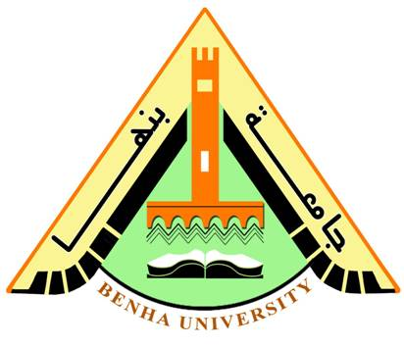
Benha University Fourth Year
Faculty of Applied Arts 2016-2017
Interior Design & Furniture Department Time: 2 hours
ــــــــــــــــــــــــــــــــــــــــــــــــــــــــــــــــــــــــــــــــــــــــــــــــــــــــــــــــــــــــــــــــــــــــــــــــــــــــــــــــــــــــــــــــــــــــــــــــــــــــــــــــــــــــ
Part I: Textbook (5 marks)
Answer the following questions:
- Art history is the study of objects of art in their historical development and stylistic contexts, i.e. genre, design, format, and style.
- interior decorators aren’t necessarily expected to have a bachelor’s degree
interior designers are expected to pursue the education that supports the profession.
- The word "close-knit" can be replaced by: c- coherent
- Interior designers are often charged with the task of taking a less than ideal space and creating something functional, beautiful and structurally sound.
- Most people have an appreciation for art as they enjoy observing it or creating it, they support it financially or by volunteering.
ــــــــــــــــــــــــــــــــــــــــ
Part II: Grammar (10 marks)
A) Complete the sentences. Use an object and the correct form of the verbs in the box:

- Her to play
- Me to give
- Him to buy
- Me to phone
- Her to come
B) Circle the correct answer:
1- at
2- about
3- Hand
4- scale
5-stressful

Part III: Collocation (5 marks)

Correct the collocations error from these sentences:

- Ran of
- Worth your while
- give
- tell
- changed

ـــــــــــــــــــــــــــــــــــــــــــــــــــــــــــــ
Part IV: Reading Comprehension (5 marks)
A- Give short answers to the following questions:
1. later-born children have to choose from what’s left.
2. It can affect and shape our personality; it could affect the success of our relationship, too..
3. Firstborns
B- Choose the correct answer:
4. According to the passage, partner could be suitable for us by his/her (a- birth order)
5. The word “exclusive” means.. c- absolute

ـــــــــــــــــــــــــــــــــــــــــــــــــــــــــــــ
Part V: Writing (5 marks)
Students can write in any of the given topics

BEST WISHES
Ansaam Alshamy

