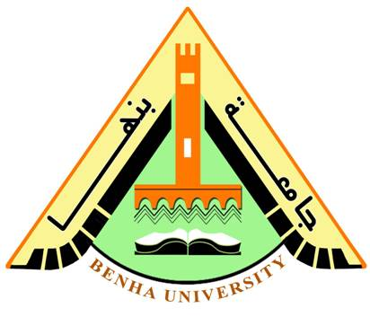
Benha University Fourth Year
Faculty of Applied Arts 2016-2017
Sculpture Department Time: 2 hours
ــــــــــــــــــــــــــــــــــــــــــــــــــــــــــــــــــــــــــــــــــــــــــــــــــــــــــــــــــــــــــــــــــــــــــــــــــــــــــــــــــــــــــــــــــــــــــــــــــــــــــــــــــــــــ
Part I: Textbook (5 marks)
Answer the following questions:
- Materials- scale- installation techniques- the use of found objects- the use of ceremonial or ritual objects- performance techniques- the importance of photography and documentation- the different perspectives and viewpoints suggested by some works.
- the additive process and the subtractive process
- another meaning to “Support” is help
- By observing the creation of people from other cultures.
- Most art pieces can create an effect on people’s state of mind and feelings. Therefore inspiring masterpieces can change people’s opinions and points of view. A picture can describe a million words. Specially detailed works make a difference into influencing people
ــــــــــــــــــــــــــــــــــــــــ
Part II: Grammar (10 marks)
A) Circle the correct answer.
I’m having a lot of problems with my motorbike and I’d really like to get a new one. But I haven’t been able to find much information about motorbikes and I’m afraid of making the wrong choice. I’d like one that’s similar to the one I’ve got, but more reliable. I know you know a lot about motorbikes, so could I ask you for advice on this? What would you recommend? Are you pleased with yours?
B) Complete the sentences. Use Prepositional phrase.
- Tell the man at the desk
- Jo is the one in/ with a red shirt
- The boy with fair hair
- The book on the left is mine
Part III: Collocation (5 marks)

Correct the collocations error from these sentences:
- Ran of
- Worth your while
- give
- tell
- changed

Part IV: Reading (5 marks)

a) Give short answers to the following questions:
1 university and school
2 300-400 students
3 as students can discuss subjects they find difficult,
b) Choose the correct answer from a, b, c or d:
4) Who does the word (they) refer to ? students
5 a) Be organized.
ـــــــــــــــــــــــــــــــــــــــــــــــــــــــــــــ
Part IV: Writing (5 marks)

Students can write in any of the given topics

BEST WISHES
Ansaam Alshamy

